Ottawa Carleton Institute for Electrical and Computer Engineering

School of Electrical Engineering and Computer Science

University of Ottawa

ELG-5383

Survivable Optical Networks

Assignment #1

**1) Devise the self-routing scheme for the 8x8 Banyan network(It means 8 inputs and 8 outputs) and shuffle exchange network.**

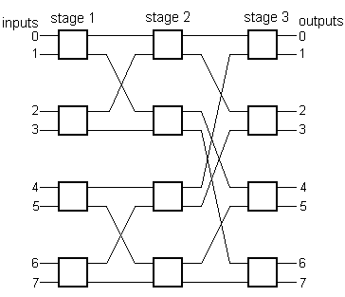

**2) Consider the banyan network shown in Figure 1 with two packets applied to inputs 0 and 4 destined to outputs 6 and 5 respectively. Show that there is an internal blocking that has occurred and explain how to use deflection routing to remove this blocking. Show how to use bridged shuffle exchange networks along with deflection routing to further reduce the probability of blocking in banyan networks.**

In this question, we are assuming that the higher priority will be given to the packets applied at input number 0 as compared to the packets applied at input number 4.

In the deflection routing, packets applied at input 4 will keep going in the alternate path. After it reaches stage number 3, it will restart from stage number 4 and route to output number 5 in the stage 6. *As stated above, the packets applied at input number 0 will be given higher priority so it will reach the output number 6 in the stage 3 without going in the alternate way.*

In bridge shuffle exchange network there is a small bridge between the switches of every consecutive stage. In this method, the packets do not get reset and it lets the packet route from the next stage itself. The packets are received at the output number 5 in the stage 4.

**3) *Calculate the total insertion loss in the network shown in Figure 2, assuming N=8, the fiber-to-waveguide loss W=1.5 dB, the excess loss in each 1:2 passive splitter and 2:1 combiner E= 0.3 dB, the insertion loss in a directional coupler L=0.5 dB.* Assume also that the network is fabricated on a single substrate, the splitters and the combiners are implemented as binary trees, and that the propagation, crossover, and bending losses are negligible.**

The explanation of the diagram 2 is as follows:

a. Here N is the number of inputs.

b. Here Black lines are fiber.

c. Waveguides are the three big boxes present in succession next to each other.

d. Splitters are the 2 small boxes present in the 1st waveguide and combiners are the 2 boxes present in the 3rd waveguide as shown in figure 2.

e. Directional Couplers are the three small boxes present in the center.

f. N/2 in the diagram indicates that there are 4 fibers coming out from the 1st splitter as the value of N is 8 as per the question.

g. The figure 2 shown below is a symmetric diagram. The 2nd and 3rd fibers coming out form the 1st splitter will go into 2nd and 3rd Directional Coupler which is not shown in the figure 2 as it is a symmetric diagram.

The complete diagram of the figure 2 is explained in figure 3. We have drawn the figure 3 as figure 2 shown is a symmetric diagram.

The question states that we have to calculate the total insertion loss in the network, therefore we have:

The fiber to waveguide loss is: (8x1.5) + (8x1.5) = 24 dB [Here we are taking the value in both the cases as there are 8 inputs and 8 outputs]

Directional Coupler Loss is: [(0.5+0.25+0.25) x 4] x 4= 16 dB [ The 1st directional coupler has a loss of 0.5 dB. The second and third both have one input shorted hence the loss become half which is 0.25. ]

The excess loss in each 1:2 passive splitter and 2:1 combiner E= 0.3 dB, therefore total loss in the splitter and combiner will be: [(3+3) x 8] x 0.3db = 14.4 dB [Here we are taking the value of 3 because there are 3 inputs per splitter and 3 combiners per output]

Therefore total insertion loss will be: (24+16+14.4) dB = 54.4 dB

Fig. 2

Fig. 1

Inputs

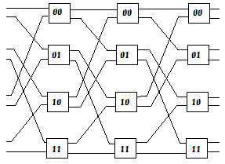

Outputs

Inputs

Fig. 1

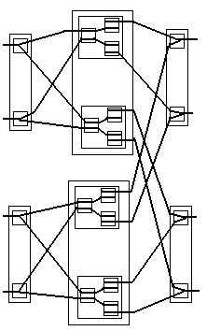

**1**

**1**

**1**

**1**

**1**

**1**

**N/2**

**N/2**

**N/2**

**N/2**

**N/2**

**2**

**2**

**N-1**

**N-1**

**N**

**N**

**...**

**...**

**...**

**...**